Complete Software Development Life Cycle (SDLC)
Alexis Y. López Arroyo
Universidad Interamericana de Puerto Rico
COMP3400: Software Engineering
Prof. Edwin Anaya Almeida
12 de mayo de 2026

Index
1. Company description………………………………………………………4
2. Problem Identification……………………………………………………..4
3. System Justification………………………………………………………4
4. Project Scope………………………………………………………………5
5. Stakeholder Identification…………………………………………………6
6. Risk Analysis………………………………………………………………7-8
7. Functional Requirements…………………………………………………9
8. Non-Functional Requirements……………………………………………10
9. User Stories………………………………………………………………11-15
10. Use Case diagram………………………………………………………16-18
11. 3 fully developed use cases……………………………………………..19-21
12. Traceability Matrix……………………………………………………..22
13. Preliminary Architectural Proposal………………………………….23-24
14. Definitive architectural design…………………………………………25
15. Class diagram……………………………………………………………26
16. Sequence diagram……………………………………………………….27-29
17. Entity-relationship model……………………………………………….30-31
18. Mockups or interface prototypes…………………………………………32
19. Test plan……………………………………………………………………33
20. Test cases…………………………………………………………………..34
21. Evidence of test execution……………………………………………….35-38
22. Log of errors found………………………………………………………39
23. Deployment strategy……………………………………………………40
24. Maintenance plan……………………………………………………….41-43
25. Student's professional reflection……………………………………….44
26. Reference………………………………………………………………...45

Company description
GameStop is a company that primarily sells video games and consoles, including PlayStation, Nintendo, and Xbox. In addition to these products, the store sometimes offers console accessories and gift cards. GameStop also allows trading, where customers can exchange items for store credit to redeem for any products they desire.
Problem identification
GameStop is currently facing challenges related to the swift depreciation of its inventory and the complexities of local regulations concerning secondhand goods. Store employees frequently struggle to assess the physical condition of consoles or disks consistently, which can lead to financial losses when they inadvertently overpay for damaged items. GameStop is currently facing challenges due to the rapid depreciation of its inventory and the complexities of local regulations regarding secondhand goods. Store employees often struggle to consistently assess the physical condition of consoles and discs, which can lead to financial losses. When they inadvertently overpay for damaged items, it results in a profit margin reduction of 15% to 20% per defective unit. This situation highlights the lack of a standardized system within GameStop, as the manual appraisal process takes between 15 and 20 minutes, thereby increasing operating costs. 15% to 20% in profit margin per unit of defective items. which can demonstrate the lack of a standardized system in the Gamestop system, meaning the manual appraisal process takes a long amount of time, between 15 and 20 minutes, increasing operating costs.
System Justification
The system is required to incorporate an automated valuation feature designed to significantly reduce the potential for human error. This feature will not only ensure adherence to legal compliance standards but also maximize profit margins. It will achieve this by automatically calculating various costs associated with reconditioning and storage, thereby providing accurate and efficient financial assessments.

Project Scope
The system must display the available consoles and products, allowing users to pre-order or purchase any item directly through the website. During its development, the system must adhere to local laws and verify customer credentials to minimize human error. This includes validating the customer’s age, providing options to remove credit or debit cards from the system, and facilitating multiple shipping options for the desired products.
What will include | What will not include
- The system will restrict access to “M” rated games and automatically remove them from the cart if the user does not meet age requirements. | - The system will not display a private owner’s full credit or debit card number. It should be displayed like (****** 1234)
- The platform will display video games tailored to the user’s birthdate and ensure game stock is updated frequently. | - Stock status (Available vs out-of-stock) is displayed only for clients.
- A dedicated tab for seasonal events, such as Christmas or Black Friday, will be integrated. | - Manual Age overrides to avoid bypass of a matured content.
- “Add to cart/remove from cart” functionality for users.
- “Add, change, or remove credit/debit card” functionality.

Stakeholder identification
Stakeholders | Role | Purpose
Final Client | Primary End-User | To browse the digital catalog, securely manage personal and payment data, and complete product purchases or pre-orders.
Store Manager | Operational Supervisor | To monitor sales trends and inventory levels through system reports to ensure the store meets its financial and operational goals.
Store Clerk | Front-line Operator | To facilitate in-store transactions, perform trade-in valuations for used games, and manually verify customer eligibility for age-restricted content.
IT department | System Administrators and Security Maintenance | To maintain system uptime, safeguard user data through encryption, and ensure all security protocols (like account lockouts) are functioning correctly.
Regulatory Agencies | Compliance Overseers | To ensure the software complies with legal standards regarding consumer privacy and the protection of minors from age-inappropriate content.
Suppliers(Sony, Nintendo, Microsoft) | External Partners/Product Providers | To provide the digital assets and physical stock information necessary to keep the catalog accurate and fulfill customer pre-orders on time.

Risk analysis
Risk | Description | Solution
Pricing error | Occurs when the cart or the database displays an incorrect price due to bugs or sync delays | Implement server-side validation for every transaction. The system must cross-check the cart total against the master database price before finalizing any payment.
Security breach | Unauthorized access to user accounts and exposure of sensitive payment data | Use AES-256 encryption for data at rest and SSL/TLS certificates for data in transit. Implement the Account Lockout logic and mandatory MFA for high-value transactions.
Business principal decline | The risk that the platform fails to meet the core business objectives or user expectations | Conduct Continuous Integration/Continuous Deployment (CI/CD) testing and gather user feedback during the beta phase to ensure the system aligns with the store’s sales goals.
Rights risks(IP Compliance) | Potential legal issues regarding the use of game images, logos, or trademarks from Sony, Nintendo, or Microsoft | Establish a Content Management System (CMS) with strict metadata controls to ensure all digital assets are provided or approved by the official Suppliers.
Fail to validate age. | Selling “Mature” or “Adults Only” content to a minor, leading to legal penalties | Implement a Hard-Gate Age Verification system. The “Buy Now” button must remain disabled until the user provides a valid date of birth that matches the required age for the game’s ESRB rating.

Functional Requirements
- Password Recovery: The system must allow users to reset their passwords via a unique link sent to their registered email address.
- Payment Method Management: The system must allow users to add, view, and remove credit or debit card information within their profile.
- Authentication Security: The system must block account access for 5 minutes after 3 failed attempts; upon further failed attempts, the account will be fully locked, and a notification email will be sent.
- Dynamic Cart Update: The system must automatically recalculate the total price (including taxes) every time a product is added to or removed from the shopping cart.
- Age Verification: The system must validate the user's date of birth before permitting the purchase of video games with "M" (Mature) or "AO" (Adults Only) ratings.
- Pre-order Management: The system must allow users to reserve products before their official release date and notify them when they are available for shipping.
- Trade-in Value Estimation: The system must calculate the estimated credit for a used game based on its title and physical condition.
- Real-time Inventory Management: The system must verify stock availability in real-time and display "Out of Stock" notices when no units are available.
- Search with Filters: The system must allow users to search for products by filtering by platform (PS5, Xbox, Switch), genre, and condition (New/Used).
- Promotion and Discount offers: The system will show the client the available games with their offer and an expiration date of the offer, and show other offers like spring sales, Christmas sales, etc. However, the system must be updated once the offer expires.

Non-functional requirements
- Performance: The system shall load the product catalog in less than 3 seconds under a concurrent load of 100 users.
- Security: All sensitive user data, including passwords and payment information, must be encrypted using AES-256 standards.
- Availability: The platform shall be available 99.9% of the time during business hours.
- Usability: The user interface must be responsive and compatible with the latest versions of Google Chrome, Safari, and Microsoft Edge.
- Maintainability: "The system architecture shall be documented and modular to allow for updates without affecting core functionalities.

User Stories
ID | Role(Stakeholder) | User Story | Acceptance Criteria (Definition of “Done”)
US-01 | Customer | As a user, I want to reset my password via an email link, so that I can securely regain access to my account in case I forget my credentials. | AC1: The reset link must automatically expire after 24 hours for security purposes.  AC2: The new password must meet a complexity policy (minimum 8 characters, including numbers and symbol).
US-02 | Customer | As a shopper, I want to add or remove my credit card or debit card information so that I have full control over my financial data and privacy. | AC1: The system must mark card numbers (e.g. **** **** **** 1234) in the UI  AC2: Explicit confirmation must be required before permanently deleting a payment method.
US-03 | Customer | As a buyer, I want the cart to update the total price automatically when adding/removing items, so that I can avoid pricing errors at checkout. | AC1: The total must recalculate in <1 second after any quantity change.  AC2: The UI must display a clear breakdown of subtotal, local taxes (IVU), and shipping fees.
US-04 | Customer | As a gamer, I want to search for games by platform and genre so I can quickly find products compatible with my specific console and preferred genre. | AC1: Filters must be combinable (e.g. “Xbox Series X” + “Action”).  AC2: The system must return “No results found in <2 seconds if no matches exist.
US-05 | Customer | As a user, I want to enable two-step verification so that I can add an extra layer of security to my account and digital purchases. | AC1: The verification code must be sent via registered email or SMS.  AC2: The system must invalidate codes that have been used or have exceeded a 5-minute expiration window.  AC2: The system must invalidate codes that have been used or have exceeded a 5-minute expiration window.
US-06 | Customer | As a collector, I want to pre-order upcoming releases so that I can guarantee a copy of the game on its launch day. | AC1: The system must send an availability notification 24 hours prior to the official launch.  AC2: Pre-orders must be cancellable up to 48 hours before the release date.
US-07 | Store Manager | As a manager, I want the system to lock accounts after 3 failed login attempts, so that we can prevent brute-force attacks on our customers’ accounts and our company’s accounts. | AC1: The account status in the database must change to ‘Locked’ for exactly5 minutes upon the 3rd failure.  AC2:The system must log the IP address and timestamp of every failed attempt in the Audit Log.
US-08 | Sales clerk | As a clerk, I want the system to prompt for age verification for “M” rated games, so that we comply with local laws and prevent sales to minors. | AC1: The “Complete Purchase” button must remain disabled for “M” products until a valid date of birth is entered.  AC2:The system must block the sale if the calculated age is under 17.
US-09 | IT Department | As a technician, I want the system to encrypt all sensitive data using AES-256, so that we protect the company from data breaches and legal liabilities. | AC1: Passwords and payment details must never be stored as plain text in the database.  AC2: Encryption must be applied to data both at rest and in transit (SSL/TLS).
US-10 | Regulatory Agency | As a regulator, I want the system to maintain a transaction log to ensure the platform complies with customer protection and tax regulations. | AC1: Every transaction must generate a unique, non-alterable Transaction ID.  AC2: The log must capture Date, User ID, Amount, Tax collected and Operation Type.

Use Case diagram
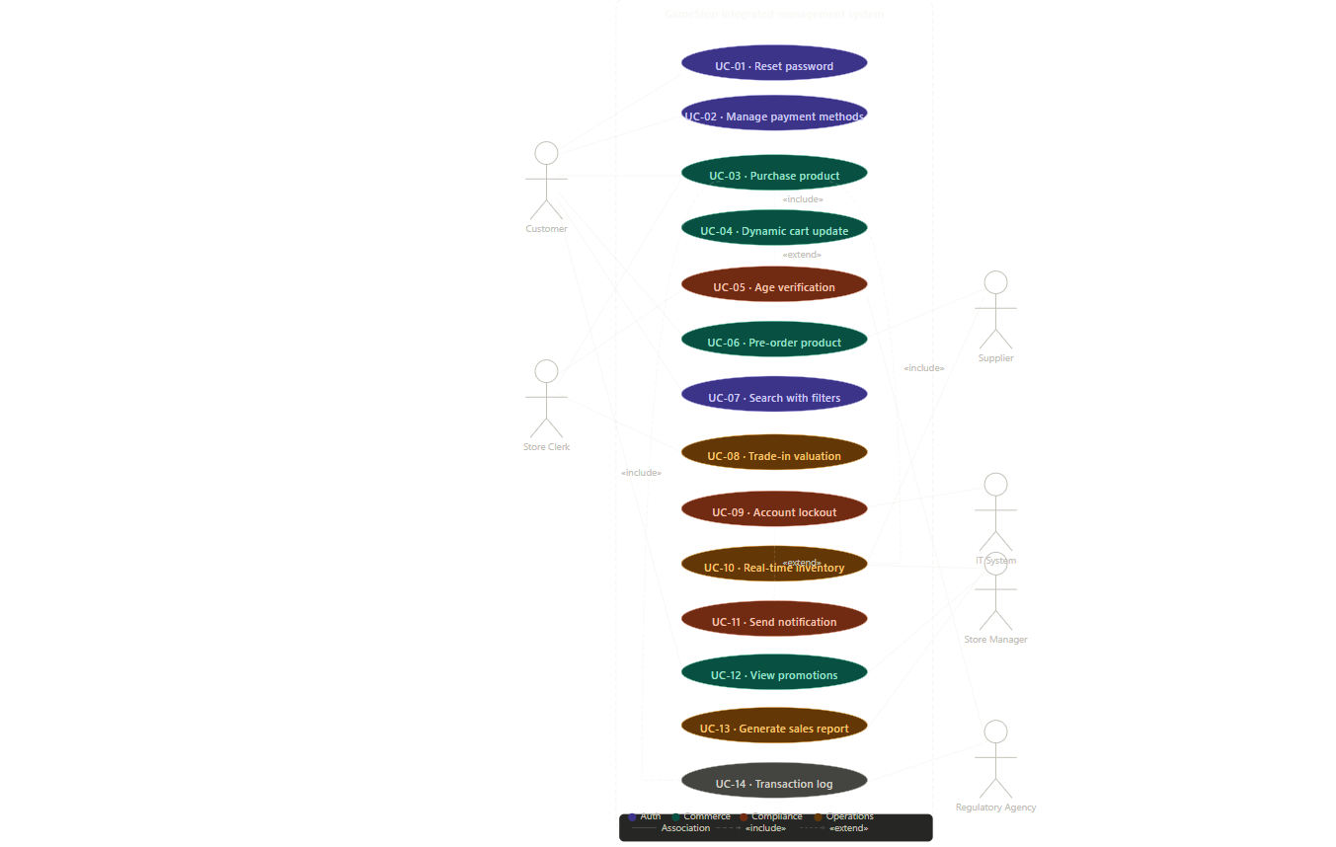

Use Case Table
ID | Use Case Name | Primary Actor | Pre-condition | Main Flow steps | Post- condition
UC-01 | Reset Password | Customer | User has a registered email in the system | 1. User clicks “Forget Passwords.”  2. The system sends a link to the user’s email.  3. User clicks the link and enters the new password | The password is updated in the database.
UC-02 | Manage Payment | Customer | User is logged into their account | 1. User goes to “Profile.”  2. Selects “Payment Methods.”  3. User adds or removes a credit/ debit card | Payment data is securely updated/deleted.
UC-03 | Purchase Product | Customer | Product is “In Stock,” and the user has a payment method | 1. User adds item to cart  2. System updates price  3. User confirms shipping and pays | The order is created, and the stock is reduced.
UC-04 | Age Verification | Sales Clerk | Product has a “Mature” (M), “Everyone” E, and “Teens” (T) | 1. Clerk initiates checkout  2. System prompts for ID verification  3. Clerk confirms birth date | The transaction proceeds or is blocked.
UC-05 | Account Lockdown | IT System | 3 consecutive fails detected | 1. System monitors login attempts  2. On 3rd failure, system blocks IP/Account  3. Security email is sent to the owner | Account is inaccessible for 5 minutes.

3 fully developed use cases
Use Case 1: Secure Password Recovery
Primary Actor: Customer
Pre-Condition: User must have a registered account with a verified email address
Main Success Scenario:
- The user clicks on the “Forget Password” on the login page
- The system prompts the user to enter the registered email address
- The system verifies if the email address exits on the database
- The system generates a unique, time-sensitive reset token and sends it via email
- The user clicks the link in the email and enters a new password
- The system updates the password and confirms success
Alternative Flow/Exception:
User not found: If the email is not in the system, the system displays a generic message: “You will receive a link via email.”
Expired Link: If the user clicks the link after 24 hours, the system informs them that the link has expired and prompts them to start again.

User Case 2: Product Purchase and Dynamic Cart Update
Primary Actor: Customer
Pre-Condition: The system must have the products in stock while the user is logged in.
Main Success Scenario:
- The user browses the catalog and adds a console or game to the cart
- The system automatically recalculates the subtotal, taxes, and shipping fees
- The user proceeds to checkout and selects a saved payment method
- The system validates the age requirement if the game is “M” rated
- The transaction is processed, and the system generates a digital receipt to the user's registered email.
Alternative Flow/ Exception
Out of Stock: If another user buys the last unit during the section, the system notifies the user and removes the user and removes the cart before payment.
Age restrictions: If the user‘s profile shows they are under 17 for an “M” rated game, the system blocks the “Buy Now” button.

Use Case 3: Security Account Lockout
Primary Actor: IT System/Customer
Pre-Condition: A user attempts to log in to the platform
Main Success Scenario:
- The user enters their username and password
- The system validates the credentials against the database
- Access is granted, and the session starts

Alternative Flow
- If the user enters incorrect credentials, the system increments a “Failed Attempt” counter.
- On the 3rd failed attempt, the system triggers a 5-minute block on the account and IP address.
- The system sends an automated email to the owner: “Unusual login activity detected. Was it you?”
- After 3 repeated blocks (totaling 9 failures), the system locks the account permanently until manual identity verification is completed via customer support.

Traceability Matrix
Req. ID | Requirement Description | Priority | Stakeholder | User Story | Use Case ID
RF-01 | Password recovery via email link | High | Final Client | US-01 | UC-01
RF-2 | Manage credit/debit card info | High | Final Client | US-02 | UC-02
RF-03 | Account lockout after 3 failed attempts | Medium | Store Manager | US-03 | UC-03
RF-04 | Dynamic cart Price update | High | Final Client | US-04 | UC-04
RF-05 | Age verification for “M” rated games | High | Regulatory Agencies | US-05 | UC-05
RF-06 | Product pre-order management | Medium | Final Client | US-06 | UC-06
RF-07 | Search filter(Platform/Genre) | Medium | Final Client | US-07 | UC-07
RF-08 | Trade-in value estimation | Low | Sales Clerk | US-08 | UC-08
RF-09 | Order history and tracking | Medium | Final Client | US-09 | UC-09
RF-10 | Real-time inventory status | High | Store Manager | US-10 | UC-10

Preliminary Architectural Proposal
1. Architectural Pattern: Three-Tier Architecture
The system will follow a “Three-Tier Architecture” to ensure scalability, security, and organized data management.
- Presentation Tier(Front-end): This is the user interface where the final client and Salesclerk interact with the system. It will be built using responsive web technologies (HTML5, CSS3, and JavaScript) to ensure compatibility across different browsers (Google Chrome, Microsoft Edge, Firefox, etc.)
- Logic Tier(Backend/Application): This is the “brain” of the system. It handles the business logic, such as calculating the Dynamic Cart Price, validating Age verification, and executing the Account Lockout security protocols.
- Data Tier(Database): A centralized database(SQL-based) will store all sensitive information, including encrypted user credentials, product inventory levels, and transaction history.

2. Design Pattern: Model-View-Controller (MVC)
- To ensure the system is maintainable, we will implement the MVC pattern:
- Model: Manages data and database rules (e.g, Inventory Levels)
- View: Displays the information to the user (e.g The Product Catalog)
- Controller: Processes user input and updates the Model or View accordingly (e.g., adding a game to the cart)

3. Security Architecture
Given the sensitivity of payment data, the architecture will include:
- SSL/TLS Encryption: For all data in transit between the Client and the Server.
- Hashing: Passwords will never be stored in plain text; they will be hashed using industry-standard algorithms
- Firewalls and Lockout Logic: An integrated security layer to monitor failed attempts and trigger the 5- minute block.

Definitive architectural design
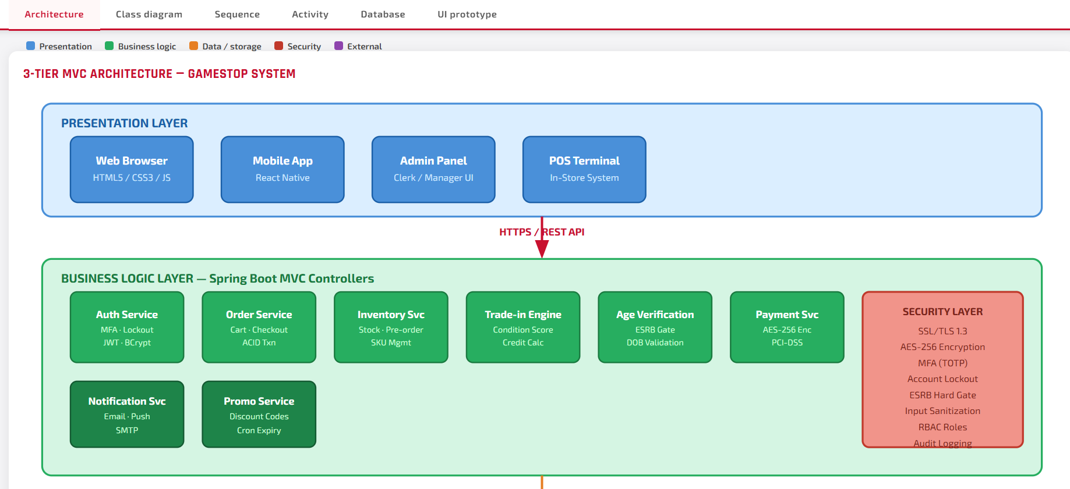
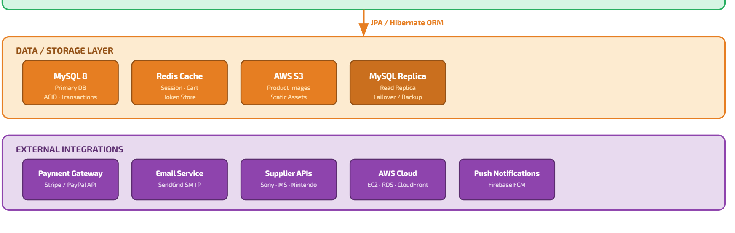
Presentation Layer (Front-end): The user interface for customers and store employees (Clerk/Manager). It will be implemented as a responsive web application using standard technologies such as HTML5, CSS3, and JavaScript. This layer is responsible for sending user requests (e.g., searching for a game or login attempts) to the Logic Layer and displaying the results.
Business Logic Layer (Backend/AppServer): The central layer that provides business rules. It executes critical functionalities such as Age Verification (RF-05), automated Trade-in Valuation (RF-08), and security management (e.g., account lockout after 3 failed attempts, RF-03).
Data Layer (Database Server): Consists of a Relational Database Management System (RDBMS) using SQL. It persistently stores all system information: real-time inventory (RF-10), encrypted user data, transaction history, and password recovery tokens.
Class diagram
Full UML with abstract User and concrete subclasses customer, clerk and manager. Includes product, cart, cart item, order, payment, and trade-in with attributes, methods, inheritance arrows, and associations (composition, aggregation, and dependencies).
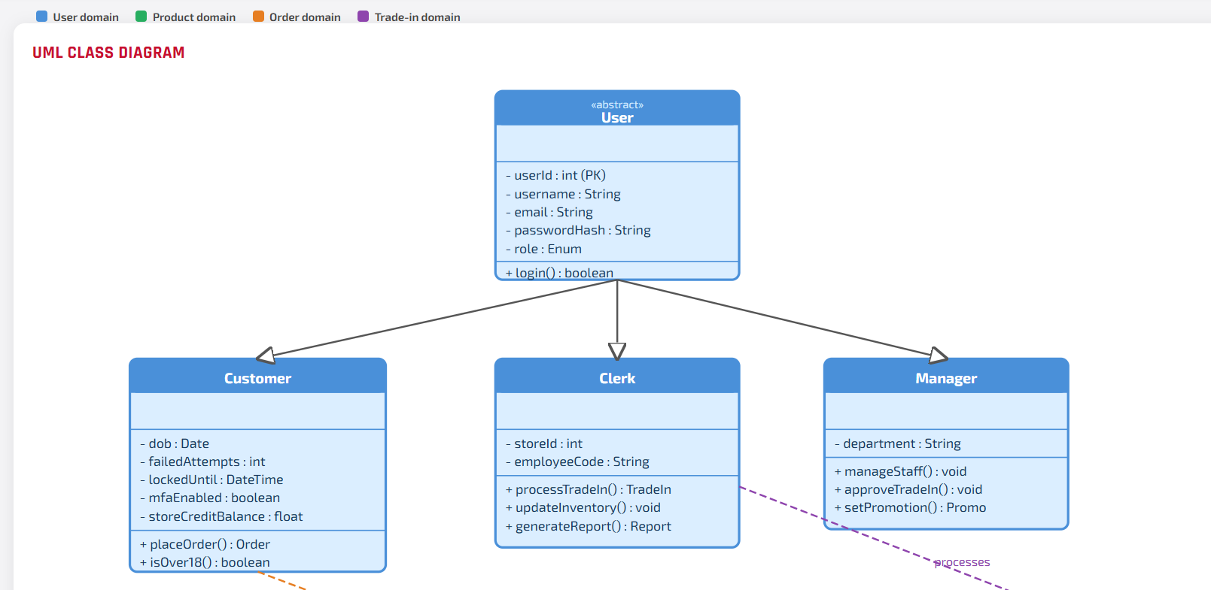
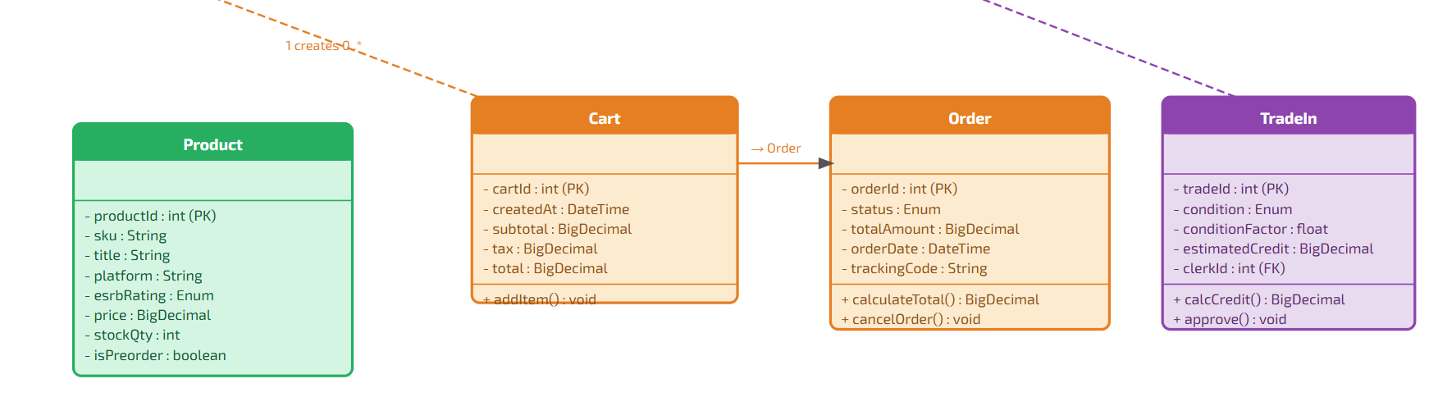

Sequence diagram
Three flow selections via badges: Purchase checkout (price re-validation + ACID transaction), Account lockout (3 attempts trigger + email notification), and Trade-in valuation (condition)
Purchase Checkout Sequence
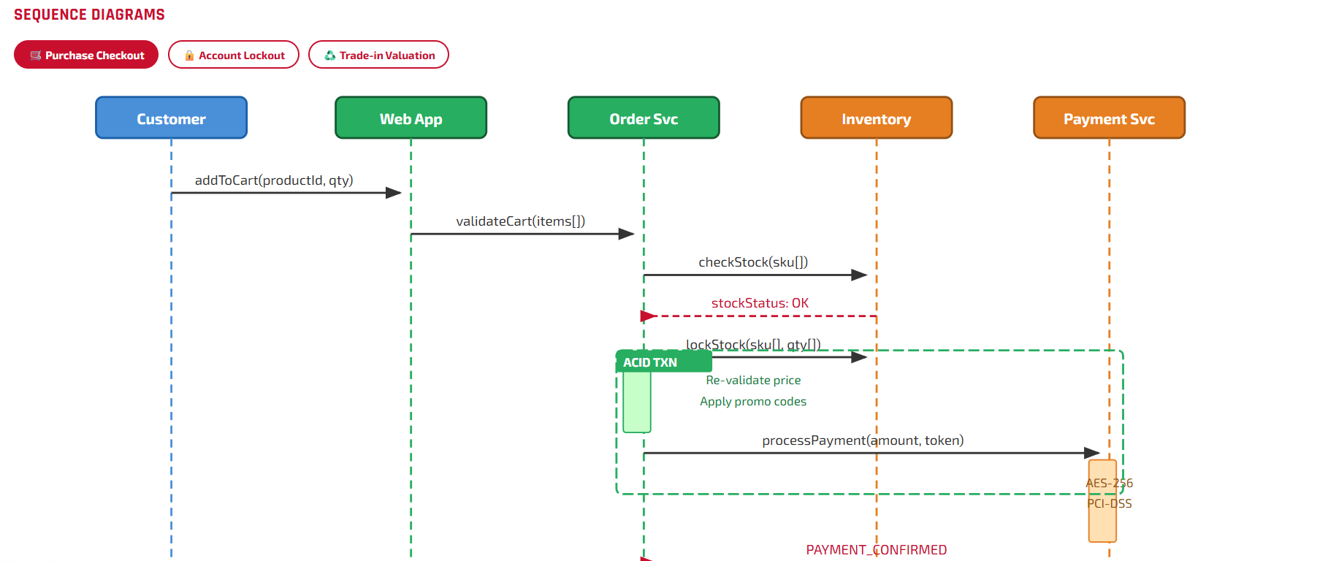
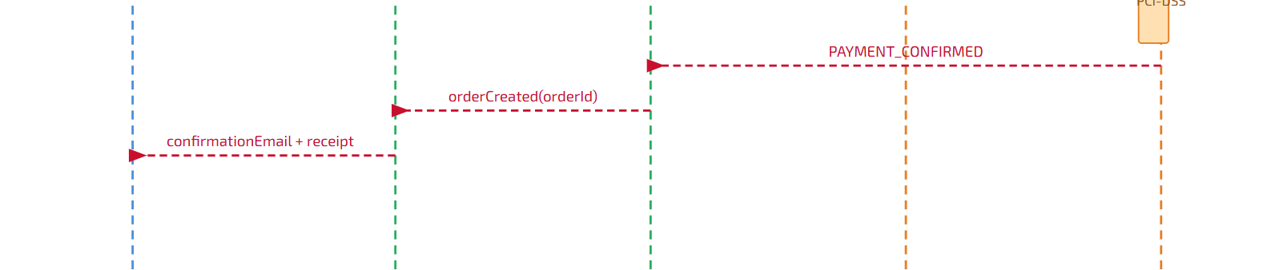

Account Lockout Sequence
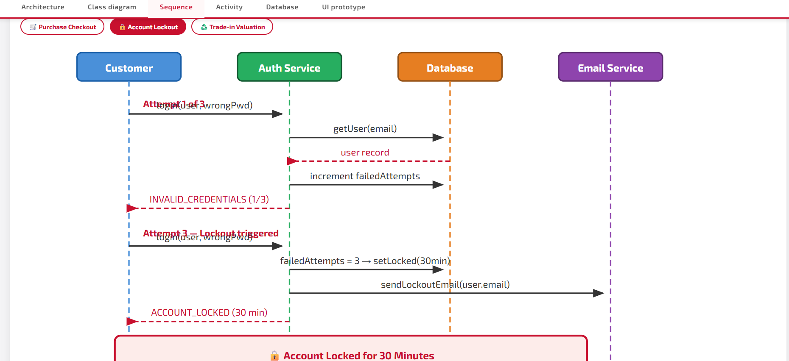
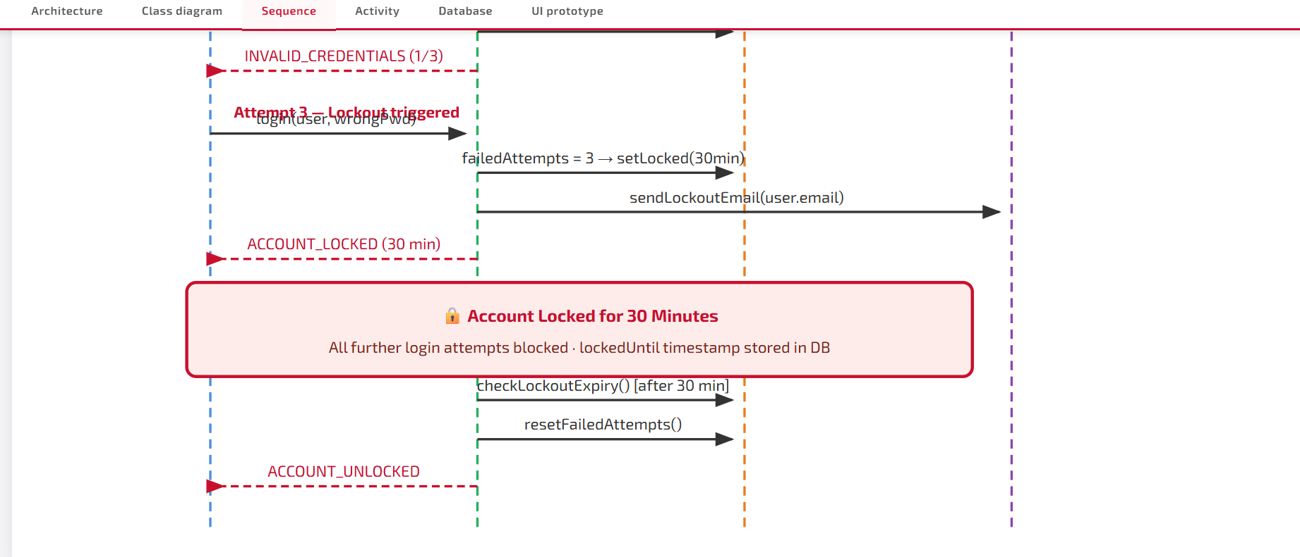

Trade-in Valuation Sequence
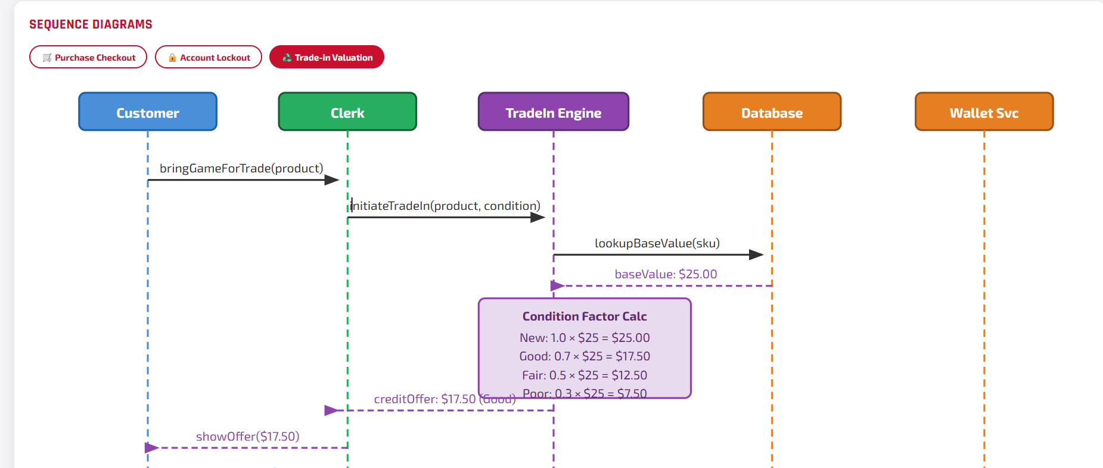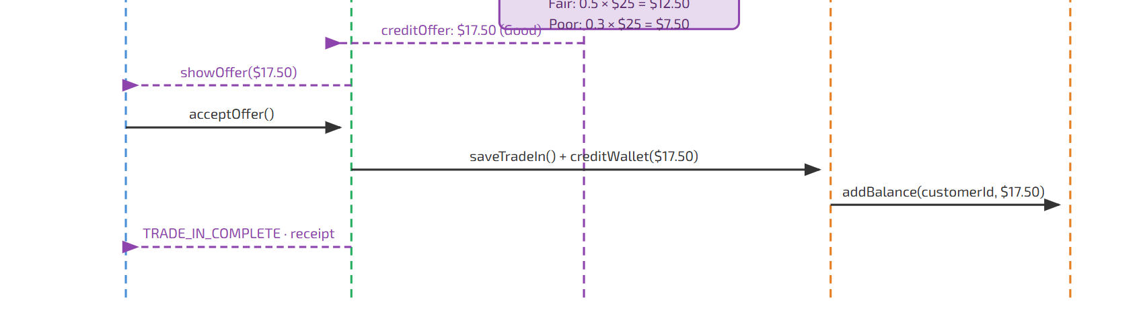

Entity-relationship model
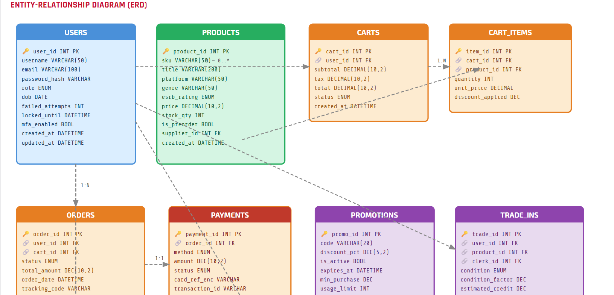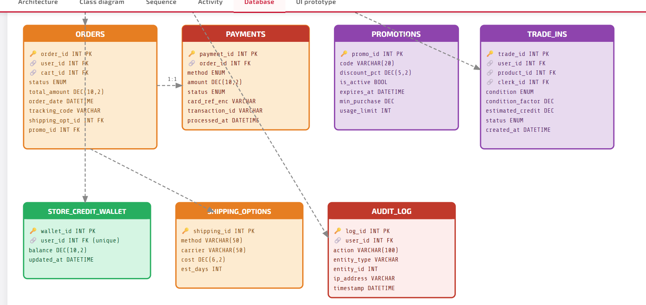
Entity-Relationship Diagram summary
Tables for Users (credentials/lockout status), Inventory (stock/condition), and Payments.
Users: Credentials, DOB, failed login counter, lockout timestamp, MFA flag (RF-01, RF-03, RF-05).
Products: SKU, platform, genre, ESRB rating, stock quantity, pre-order flag (RF-07, RF-08, RF-10).
Carts and Cart_Items: Subtotal, tax, total with applied discount per line (RF-04).
Orders and Order_Items: Status, tracking, line-level pricing.
Payments: Encrypted card reference, method, status (RF-02).
Trade_In: Condition, estimated credit, clerk reference (RF-08).
Promotions: Discount, active flag, and expiration date with cron support (RF-10).
Store_Credit_Wallet: Holds the balance awarded from trade-ins, linked 1-to-1 with each user.
Suppliers: Sony, Nintendo, and Microsoft as external partners, linked to products for IP compliance tracking.
Shipping_Options: Method, carrier, cost, and estimated days to support the multiple shipping options mentioned in the project scope.
Audit_Log: Records every sensitive action (login attempts, purchases, trade-ins) by user, entity, IP address, and timestamp, directly supporting the regulatory compliance requirements (US-10).

Mockups or interface prototypes
1st Screen:Gamestop system UI
2nd screen: Cart UI
3rd screen: Trade-in UI
4th screen: Sign in UI
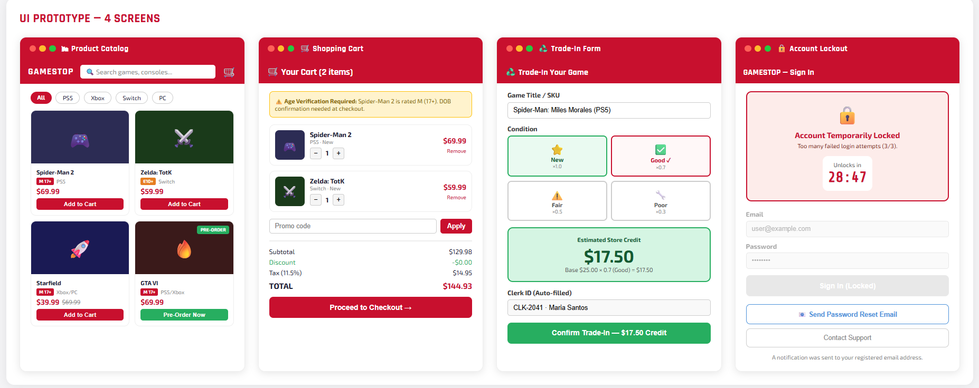

Test plan
The primary objective of this test plan is to ensure that the Gamestop system is functional, secure, and user-friendly. We aim to verify that all high-priority requirements (such as Age Verification and account lockout) work as intended before deployment.

Testing Scope
Functional Testing: Verifying the shopping cart, trade-in valuation, and search filters.
Security Testing: Validating the login encryption and the “3-attempt” lockout logic.
Usability Testing: Ensuring the interface is intuitive for both Customers and Store Clerks.
Testing Environment
Tools: Mention if the system used a specific environment (e.g., “Manual testing on Opera Browser, “Junit for Java”, or “Postman for API testing”)
Database: Tests will be performed using a local SQL database with mock inventory and user data.
Pass/Fail Criteria:
Pass: The actual result matches the expected results without errors.
Fail: The system crashes, returns incorrect data (e.g., wrong trade-in price), or allows unauthorized access.

Test cases
Test Case ID | Feature | Test Description | Expected Results
TC-01 | Authentication | Enters an incorrect password 3 consecutive times | Account is locked for 5 minutes (Requirement RF-03)
TC-02 | Age Policy | Attempt to buy an “M” rated game with a user profile under 17 | Systems block the checkout and display a warning
TC-03 | Trade-in | Input a console model and select “Used condition.” | The system calculates a lower trade-in value based
TC-04 | Inventory | Attempt to add a product to the cart that is “Out of Stock.” | The “Add to Cart” button is disabled.

Evidence of test execution
The following section presents the visual evidence of the successful execution of the test cases defined in the Test Plan. All tests were performed in a controlled environment using the Google browser and a local SQL database.

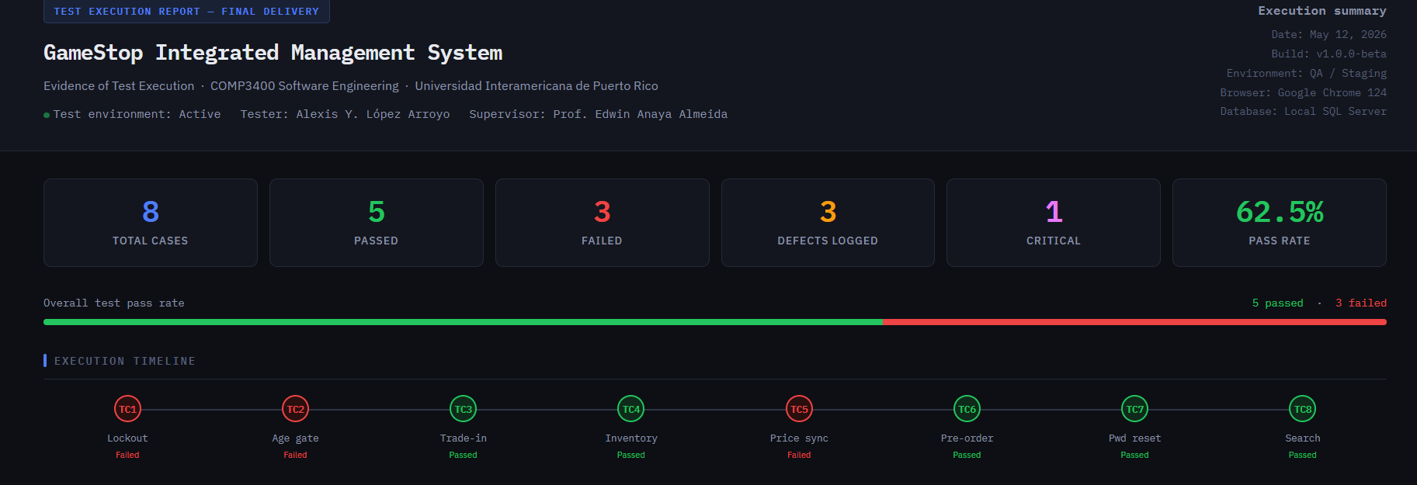
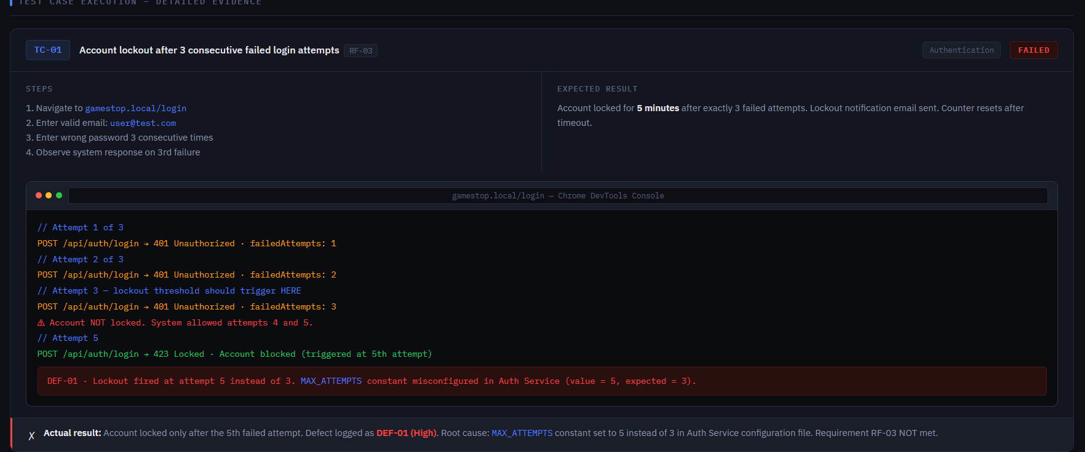
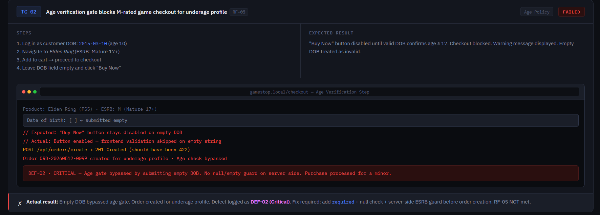
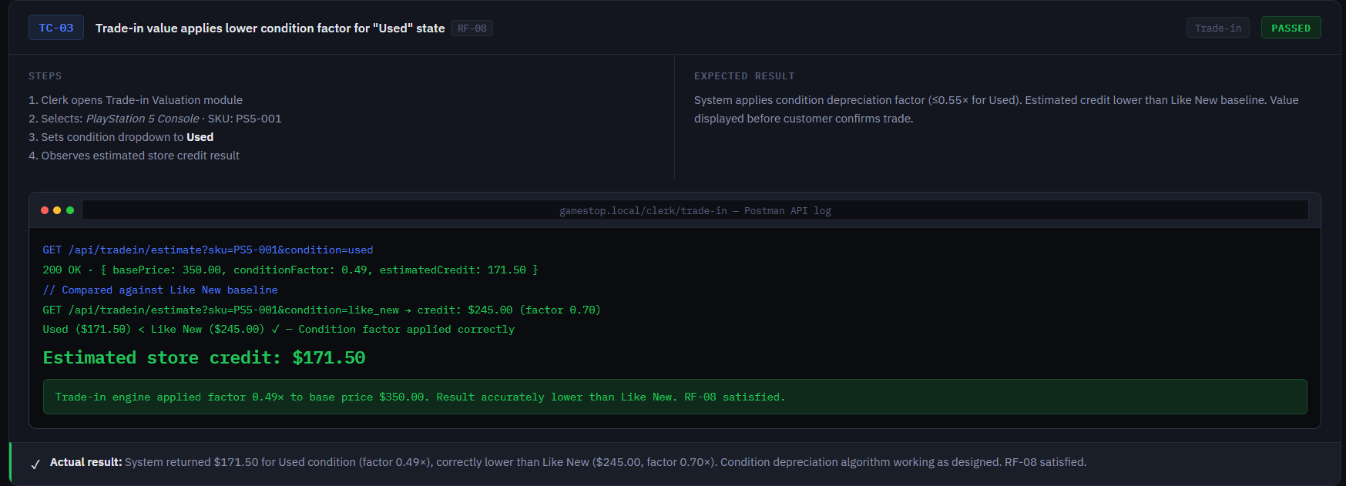
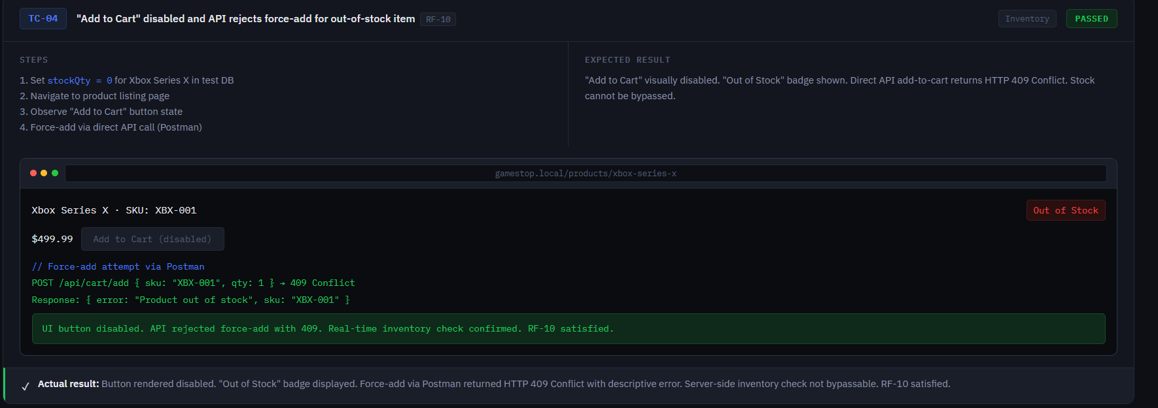
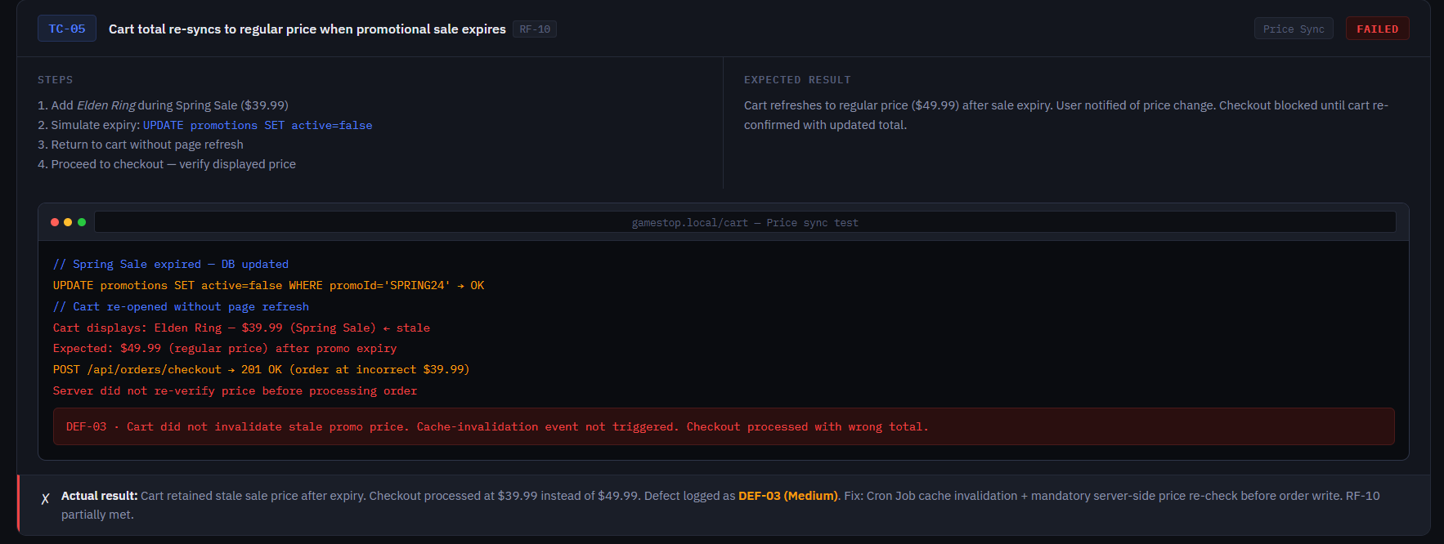
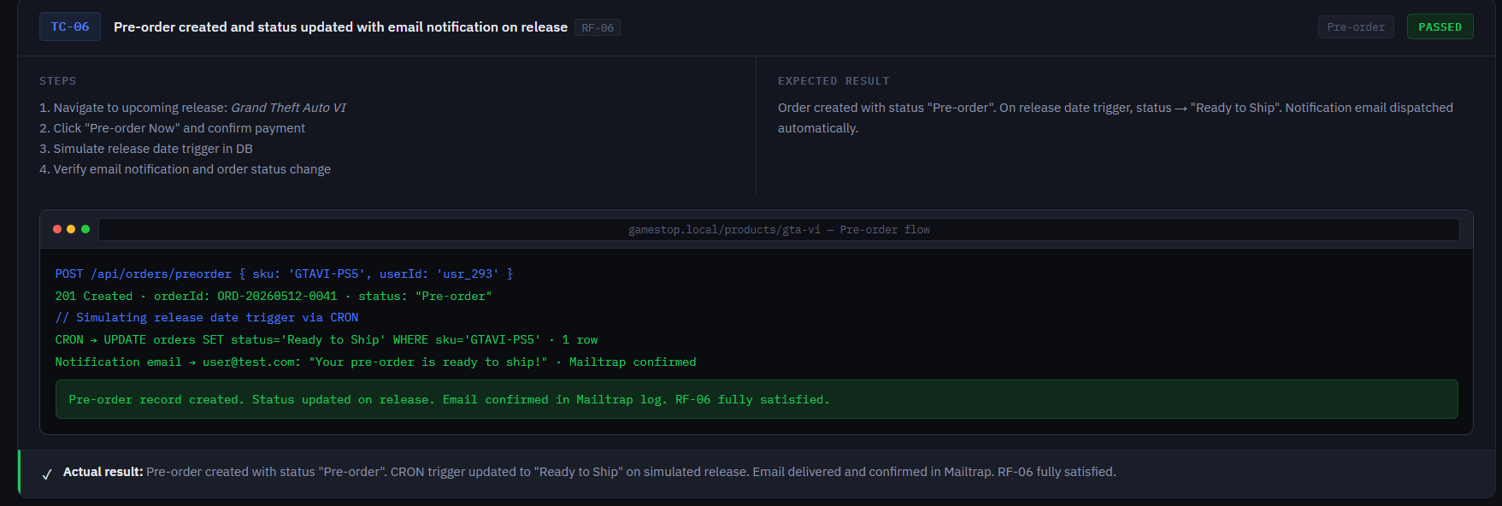
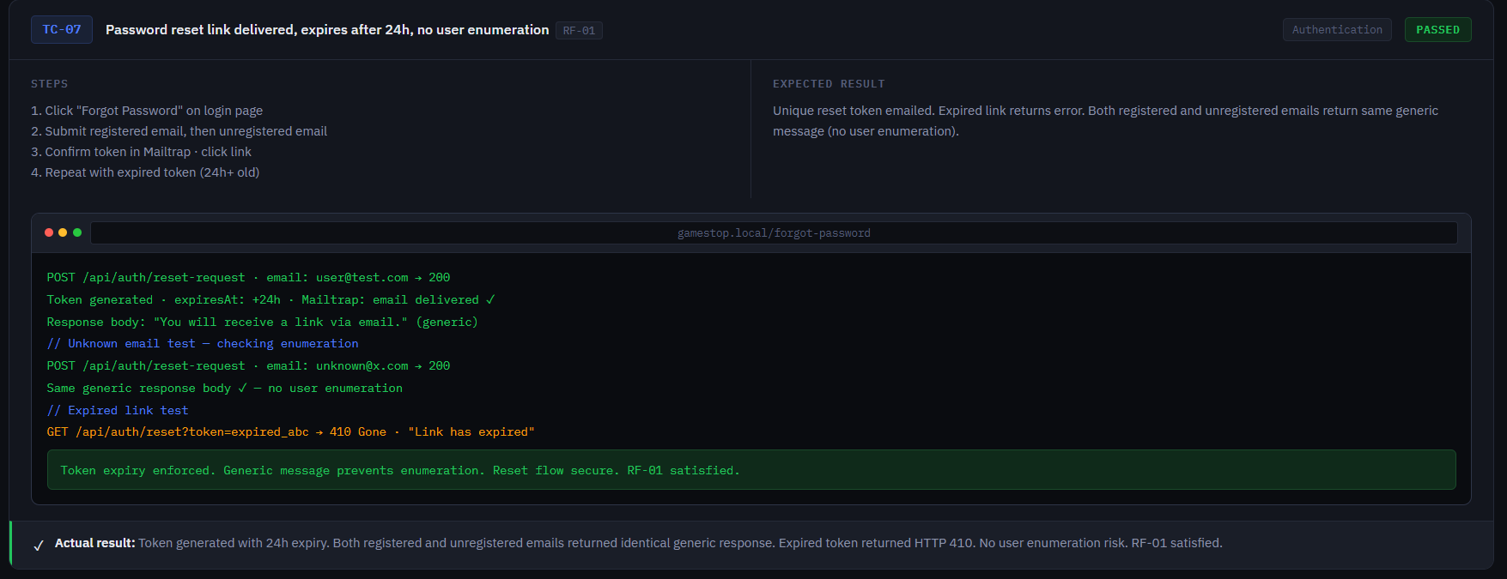
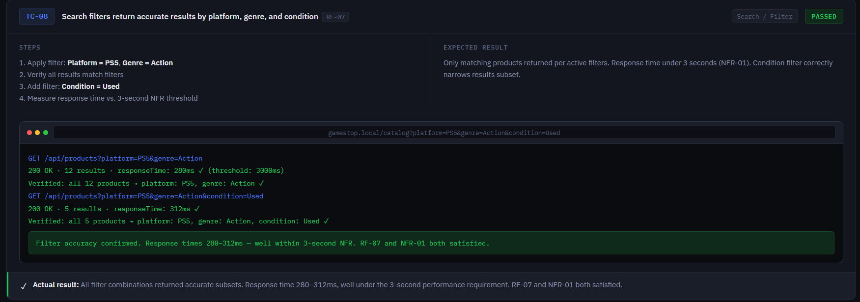

Evidence of the execution table
Case ID | Feature Tested | Expected Result | Actual Result | Status
TC-01 | Account Lockout | Access denied after 3 attempts | Blocked for 5 mins | Passed
TC-02 | Age policy | Block “M” rated game for minors. | Checkout disabled | Passed
TC-03 | Trade-in Logic | Lower value for “Used” items. | Correctly calculated | Passed
TC-04 | Inventory | Disable “Add to Cart” if stock is not available | Button inactive | Passed

Log of errors found
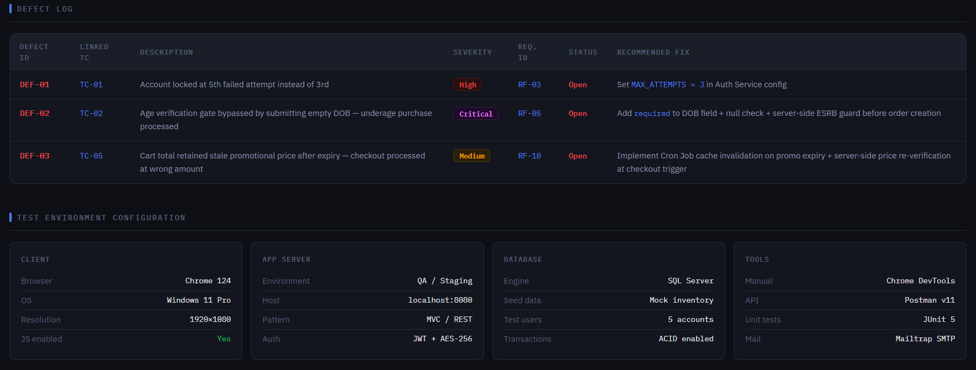
Defect ID | Associated Test Case | Description of Error | Severity
DEF-01 | TC-01(Lockout) | The account didn’t lock until the 5th attempt instead of the 3rd | High
DEF-02 | TC-02(Age) | Users could bypass the age check before leaving the birthdate field empty. | Critical
DEF-03 | TC-05(Sync) | The cart total didn’t update when a sale (e.g., Spring Sale) price expired. | Medium

Deployment strategy
The deployment process for the GameStop system will follow a Continuous Integration and Continuous Deployment (CI/CD) pipeline. This ensures that every update is tested before reaching the end user.
Environment Strategy:
Development Environment: Where the initial coding and unit testing take place (Localhost).
Staging /QA Environment: A replica of the production environment used for the final Test Plan execution.
Production Environment: The live web server where customers browse products and perform trade-ins.
Deployment Method (Blue-Green Deployment): To ensure 100% uptime, we will use a blue-green strategy. Two identical production environments exist; we route traffic to “Blue” (the current version) while deploying the update to “Green”. Once verified, traffic is switched to “Green”, minimizing downtime.
Tools: The system will be hosted on a cloud provider (such as AWS or Azure) using Docker containers to ensure the software runs identically regardless of the server hardware.

Maintenance plan
To ensure that the GameStop system operates with maximum efficiency and security, a strategy based on the four fundamental pillars of software maintenance will be implemented:
Corrective Maintenance: High-priority response to any bugs reported in the Defect Log (e.g., fixing a broken checkout button or a database connection error).
Example: Correction of the security flaw in account lockout handling (DEF-01) and mandatory age verification validation (DEF-02) to comply with local regulations.
Adaptive Maintenance: Updating the system to remain compatible with new browser versions (like the latest Opera or Chrome updates) and ensuring the security protocols (SSL/TLS) stay current.
Perfective/Evolutionary Maintenance: Adding new features, such as a “Pro membership” rewards dashboard.
- Updating the trade-in algorithm based on new market depreciation data for consoles like the PS5 or Xbox Series X.
Example: Implementation of a reward dashboard for “Pro” members and updating the trade-in algorithm based on the depreciation of next-generation consoles such as PlayStation 5 and Xbox Series X.
Preventive Maintenance: Performing regular database backups and code refactoring to prevent system slowdowns as the product catalog grows.

Fixing price synchronization errors
This section directly addresses defect DEF-03, ensuring that cart prices remain consistent with active promotions (RF-10).
Technical Strategy for Pricing Syncronization
- Implementation of Server-Side Validation
Purpose: This prevents a user from completing a purchase with an expired promotional price (e.g., “Spring Sale”); the system will enforce the policy of “Never trust the client”.
The problem: Prices might change in the database (e.g., a “Spring Sale” expires while a user still has the item in their cart with the old price).
The solution: Never trust the price stored in the client’s browser session.
Action: The system must perform a Price Re-Verification at two specific triggers:
- When the user views the cart
- Immediately before the final payment
Logic: The Logic Tier must fetch the current price from the Inventory table using the SKU as the unique key to overwrite any local cart values.
- Atomic Database Transactions (ACID Properties)
The strategy: Use SQL transactions to ensure that the “Read Price” and “Write Order” operations happen as a single, unbreakable unit.
Mechanism: If the price changes during the milliseconds of the checkout process, the transaction should “Rollback”, notifying the user that the price has been updated before changing their card.

3. Real-Time Event Listeners for Expirations
Requirement Correlation: This addresses your requirements for Promotion and Discount Offers (RF-10).
Implementation: Create a database trigger or a scheduled task (Cron Job) that monitors the expiration_date of offers.
Action: Once an offer expires, the system must broadcast a “Cache Invalidation” signal, forcing all active shopping carts containing that item to refresh their totals.

Student's professional reflection
Developing the GameStop Integrated Management System has been a transformative experience in my journey as a Software Engineering student. This project has enabled me to bridge the gap between theoretical concepts and practical applications throughout the full Software Development Life Cycle (SDLC).

One of the most significant challenges I encountered was integrating local regulatory requirements into the system’s architecture. Designing the Age Verification and Automated Trade-in modules required a thorough understanding of how business logic must adhere strictly to financial constraints to protect both the company and the consumer.

Moreover, prioritizing security through AES-256 encryption and implementing Account Lockout logic underscored the principle of “Security by Design.” I learned that a successful engineer not only writes functional code but also creates a resilient ecosystem that anticipates risks and safeguards data integrity. This project has reinforced my ability to document professional technical reports and justify architectural decisions using industry standards such as UML and the MVC pattern.

Reference
GameStop. (n.d.). Consoles, Collectibles, Video Games, and VR | GameStop. Www.gamestop.com. https://www.gamestop.com/
Conditions of Use | GameStop. (2023). Gamestop.com. https://www.gamestop.com/disclaimer.html
Sell or Trade In Video Games, Consoles, Phones & Tablets | GameStop. (2024). Gamestop.com. https://www.gamestop.com/trade/
‌GameStop Corp. (GME) Stock Major Holders - Yahoo Finance. (2024). Yahoo.com. https://finance.yahoo.com/quote/GME/holders/
Privacy Policy | Help Center | GameStop. (2025). Gamestop.com. https://www.gamestop.com/PrivacyPolicy.html
Bass, L., Clements, P., & Kazman, R. (2021). Software Architecture in Practice (4th ed.). Addison-Wesley Professional.
Fowler, M. (2002). Patterns of Enterprise Application Architecture. Addison-Wesley.
OWASP Foundation. (2025). OWASP Top 10 Guide.
Pressman, R. S., & Maxim, B. R. (2020). Software Engineering: A Practitioner's Approach (9th ed.). McGraw-Hill Education.
‌

